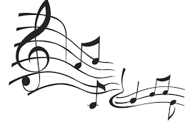

Be a Part of the Band - Audie Murphy Middle School Band

Our program has students from 6th-8th grade. Most kids who start band in Middle school for the first year have zero experience. This is great as we start from the very beginning such as learning to read music, and how to play the instrument.

Our local music store is Music and Arts, 212 W. Veterans Memorial Blvd., Harker Heights, TX 76548. Phone number is 254-680-2734

FAQ’s:

1. ***We have a used instrument at home. Is it OK for our child to play it?*** Please make sure that any instrument you are considering is of good quality and in good repair. The early stages of playing an instrument are challenging, and an inferior instrument can cause extra frustration for your child. It is best to have your used instrument checked out by a certified music repair technician and any repairs completed prior to the start of classes. The music store will advise you if the instrument is appropriate for your child, and if necessary, provide you with a repair estimate if you desire.
2. ***What should we know before purchasing an instrument?*** Most parents will choose to rent an instrument rather than purchase one right away. If you decide to purchase, you should know that there are a number of very low-quality instruments that have been flooding the market in recent years. Many of these instruments are advertised on internet auction sites or found at discount stores or wholesale clubs. While these instruments appear to be an inexpensive alternative, they almost always become a source of frustration for due to their poor construction and non-standard parts. These instruments often play very out of tune, have an inferior sound, and generally cannot be repaired! We have, unfortunately, seen several families purchase an instrument of this type, only to find in a few months that it is no longer usable. Before making a purchase, parents are strongly encouraged to contact the music store or band director for information about recommended brands of instruments and trusted dealers. You should also check with the place of purchase to make sure they can provide quality repair for the instrument. Instruments should be traditional colors.
3. ***How much time should my child devote to practicing at home?*** Home practice is important to your child’s success. Students who maintain a regular practice routine enjoy their music class more and demonstrate more consistent progress. An average of 15-20 minutes per day is recommended for the beginning student.
4. ***Can my child participate in instrumental music and sports/ after school clubs?*** YES! Because band classes meet during the school day, there is no conflict with sports or other after school activities. Our campus works together to avoid conflicts and comes up with a plan if any arise. Our evening activities are limited to three or four times per year when we present our concerts. Dates for these events will be given to parents in the first months of school.

**Contact – Jolitha Dominguez, Audie Murphy Middle School Band Director**

**Phone: 254-336-6530 Email:** [**jolitha.dominguez@killeenisd.org**](mailto:jolitha.dominguez@killeenisd.org)

**Current AMMS kids should schedule an after-school time with a parent to test instruments**

**March 28- 30between 4- 6 pm**

**New to Audie Murphy kids should schedule a time after school with a parent on April 4-5, or April 7-8 between 4-6 pm**

**Call or email the contact information above to test an instrument.**

**The following link will lead to a demonstration of instruments.**

<https://www.youtube.com/watch?v=QR3w3S5-7Zo>

Instrument choices are:

Flute Trumpet

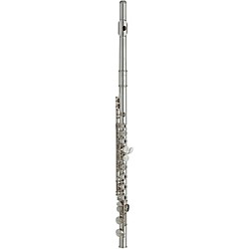 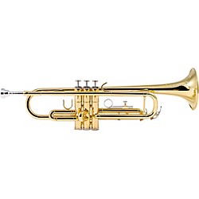

Clarinet Trombone

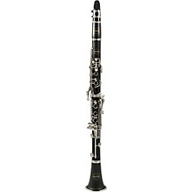 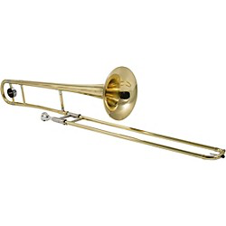

Alto Saxophone Percussion

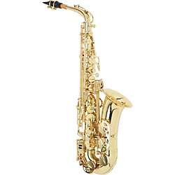 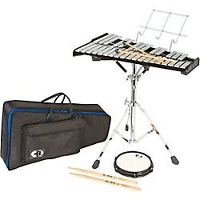

*French Horn *Euphonium (Baritone)

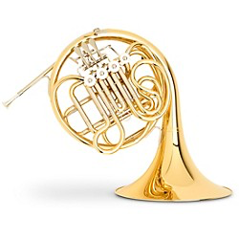 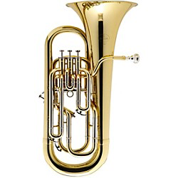

*Tuba

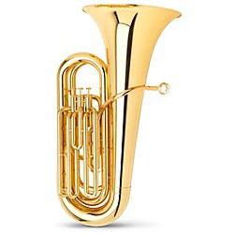

* Indicates school owned instruments that are checked out to students for student use throughout the year.